Master of Rock Device and App

- Development and Course Notes -

# 1 | Project Idea: Master of Rock Guitar Hero Device and App

What if there was a device similar to Guitar Hero, which represented the original instrument more accurately? Current devices have five or six buttons and one switch for the strummer bar.

Figure 1 | Guitar Hero Standard Guitars

Guitar Hero offers an excellent opportunity for entertainment; however, it hardly contributes to its users' musical education apart from improving fine motor skills and rhythm sense due to its enormous layout difference compared to the original instrument. Nevertheless, with the proper set of 20 ( or 24) possible finger positions and six-string switches, it might be possible to turn this device into a multi-purpose digital input and build an application around it that is entertaining and seamlessly educational.

This input device could be used for:

* Learning the layout and notes of a guitar,
* Follow app instructions to practice scales,
* Play actual music,
* Learn songs and riffs,
* Learn to read guitar tabs,
* Practice at night,
* Compete with others,
* Practice anywhere without the nuisance of the volume,
* Compose new songs and use monochrome.

The very same time and effort that users spend pressing seemingly arbitrary buttons on a plastic mock guitar could be used to acquire practical knowledge.

Similar devices, apps and inventions:

* Guitar Hero,
* **Digital Guitar** https://www.digitalmusicnews.com/2016/08/01/mi-guitar-easy-to-learn-or-cheating-your-way-to-a-guitar-experience/
* Frets Zealot Fretboard Guitar System,
* Fanville Portable Wooden Pocket Guitar Practice Tool Chord Trainer Finger Exercise Gadget for Beginner Guitar Picks and Finger Strengthener Tool,
* Guitar Riff Pro App,
* All available guitar tablature readers.

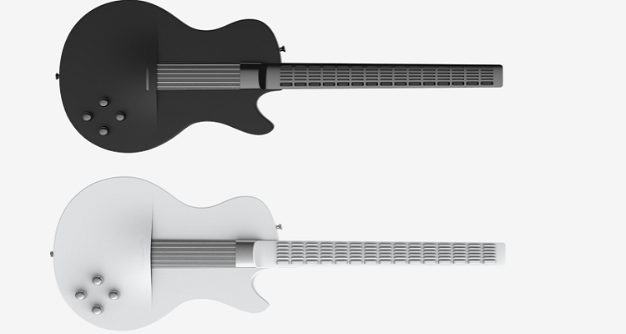

Figure 2 | Digital Guitar

**Challenges**: writing an application that listens to a device's input is not the most significant challenge. However, creating an instrument that handles 20 fret switches and six pieces of strings switches, a USB or Wifi connection that sends user actions to the PC is. Moreover, the device should not only resemble an actual guitar but must be comfortable enough to use. Finally, given the resources and the timeframe, our device and the application would instead serve as proof of concept.

**Approval Form:**

* Title
* Introduction (from general to specific)
  + Topic
  + Background
  + Abstract
* Aim and objectives
* Concept, description,
* Scope, specification, requirements, challenges, benefits, feasibility
* Research and Literature Review
  + Patents
  + Finding Gap
  + Marketability,
  + Feasibility,
  + Cost,
  + Litigations,
  + Limitations and Timeline,
  + Critical Review,
  + Risk Analysis,
* Methodology(Spiral, Waterfall): analyse four and choose one ( two ) (linear – hardware, iterative - software) importance, advantage, disadvantages
* Work Breakdown Structure, Gantt Chart (use ProjectLibre free GantChart project application)

**Strum bar parts:**

https://www.bytearts.com/strumfixplus

# 2 | Concept Diagram

Figure 3 | Concept

I took the freedom to be creative with the naming, so why not combine the two central aspects of the project, namely, Digital and Guitar? DiGitar.

# 3. | Standard Music and Tabular Notation (Literature Review)

**Introduction 1st version**

Lucky that Sound Exists in Earth -> Ancient Civilisations -> Innate Capability for Musicality -> Music in Everyday life -> Technology Appears -> New Instruments -> Never so Extended Audio Spectrum -> Digital Music -> Gaming

We, Earthly creatures, are very fortunate. Extremely few places in the vast vacuum-filled Universe have a suitable medium that supports audio signals to travel. However, here on Earth, sound vibrations can move through the atmosphere, providing information about our environment. As a result, mammalian evolution adapted to transform soundwaves into electrical signals, engineering us genetically to detect sounds. Hearing sounds increased our survival chances by identifying danger outside our visual zone and extending our communication channels.

Even though humans are not the only species communicating by creating sounds, we invented a way of self-expression that conveyed broader spectrums of emotional range beyond spoken words; music. And from as early as 40000 years ago, music has played an essential part in our everyday life. Our humans' innate musicality drove us to experiment with new ranges of sounds, inventing the primary types of instruments. Ideophones (clapping and bells), membranophones (drums), aerophones (flute), and most importantly, chordophones (harp).

Although the exact origin of the modern guitar is debated, the instrument is already mentioned in the Bible, and it can be traced back to the Greek kithara **κιθάρα** or Arabic qitharah **قيثارة** words. By the 17th century, it became popular among amateurs; and with the advent of the jazz age, the electric guitar had elevated to the instrument of the virtuosos and rock stars. However, this is not the final step for the guitar on the evolutional ladder. The modern digital era opens opportunities to combine the latest technology with musical skills. This project will attempt to bring digital technology, entertainment, art and education under the same roof.

**Audio vs Sound (Terminology)**

**The key difference between sound and audio is their form of energy. Sound is mechanical wave energy (longitudinal sound waves) that propagates through a medium causing variations in pressure within the medium. On the other hand, audio is made of electrical energy (analogue or digital signals) that represents sound electrically.**

Figure 4 | Audio vs Sound

**Chord (Terminology)**

**Riff (Terminology)**

**Clarify with Supervisor:**

* Do cover quotes and images require references?
* Is the tools section in the Introduction?
* What is the correct term for academic supervisor?
* What is the word limit on a bachelor's final year dissertation project?
* Do I need to reference the bibliography?

**0. |Reference Suggestions**

* Digitalisation in the music industry and entertainment

https://pubs.aeaweb.org/doi/pdf/10.1257/jep.31.3.195

* Musical Instrument Taxonomy 5 main types

https://www.goshen.edu/academics/music/mary-k-oyer-african-music-archive/instrument-classification/

**Appendix**

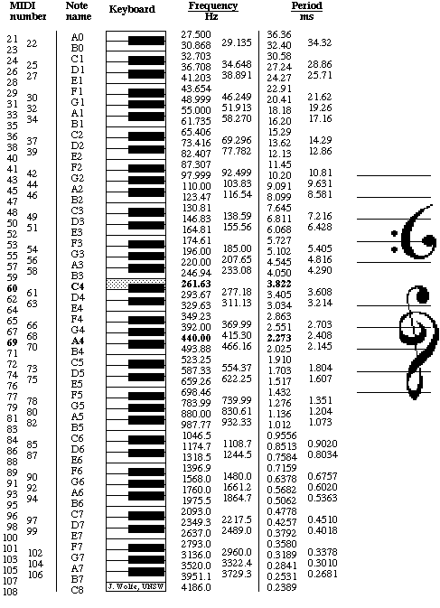

Figure 5 | Notes and Frequencies

Figure 6| Standard Music Notation

https://www.istockphoto.com/vector/music-notes-and-symbols-set-stock-vector-illustration-gm1291815513-386828576

Figure 7 | Cover Photo

https://www.wallpaperflare.com/boy-playing-the-guitar-on-the-road-music-musician-musical-instrument-wallpaper-wdokr